First, make a Github account and then go to <https://github.com/flaghunters/Extra-Flags-for-4chan>. This is the official extra flags script made by PK and will be referred to as the “official script”. In the upper right hand corner, you’ll see three sets of buttons. Click the furthest right, the “fork” button.

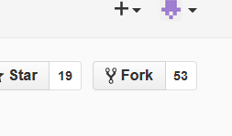

Figure 1: Fork Button

This will clone the official version of the script. Now, you are free to edit this fork. First thing I would do is go to the Javascript file “Extra flags for int.user.js” and click it. Then, click the pencil, then find the text box above the editing panel. It should read “Extra _flags_for_int.user.js”. Change this name by editing the text in front of “.user.js” to something else. This way, people do not have to install over the official script if they want to use yours.

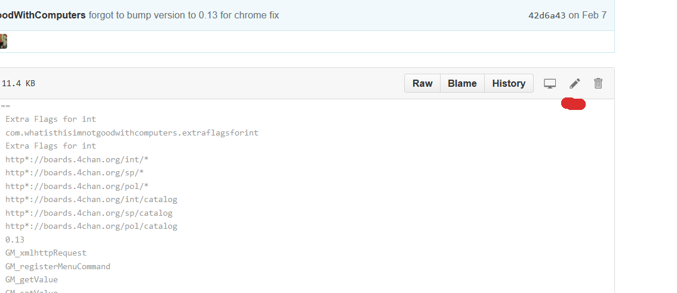

Figure 2: Editing a text-based file

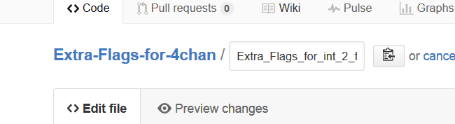

Figure 3: Rename the file by editing the text box

Next, go down to lines 19 and 20 in the script. In the @updateURL and @downloadURL, replace the link with the link to your script. You can get this by copying the web address of the current page and replacing “edit” with “raw”. This is for auto-updating the script whenever you make changes to this file.

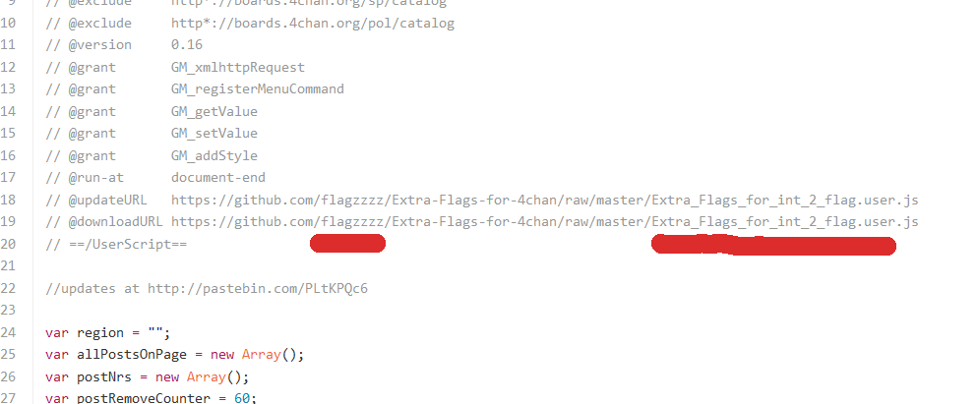

Figure 4: Change these values

Open another tab and go to your fork. Go into the flegs folder, then go to the bottom of the folder and click the image titled “empty”. Then, click the “raw” button that is above the image. Copy this web address then go back to the first tab. Find line 29 and replace the string inside the ‘ ‘ with that web address. Delete the “empty.png” off of the string so that the string now ends in /flegs/. You can now save this file.

Congratulation! You have set up the script to reference the files within your repository. You can now toy around with uploading flags into the “flegs” folder. Google is your friend from now on, as is your coding knowledge. JavaScript is very easy to learn, especially if you know Java.

**Displaying Flags**

First, make a flag you would like to add. It needs to be a png file and at most 16x11. You can change this size restriction in the code if you are up to it. Be sure to note what you name the file.

Upload it into the flegs folder without worrying about putting it into a sub folder. Then, break open that JavaScript file you edited a few seconds ago and head down to lines 161-176. Delete what is underlined in red. In the official script, this tells the script to look into the specific country folder the poster is posting under. Save this script.

Now go back to your fork and click the user.js file once more. Press the “raw” button and a download dialogue should pop up. Press “install” and go back to /int/. Since you are adding your own flag, you do not necessarily need to disable other extra flag script, but I’ll tell you how to do it anyways. Go to the GreaseMonkey/TamperMonkey script menu and disable any extra flags script you might have running so only your own is running. Then, go to the “Set up extra flags” menu, and enter your region name. This will be whatever you named your flag **without** the .png extension. Press save and put a test post. Your flag should show up.

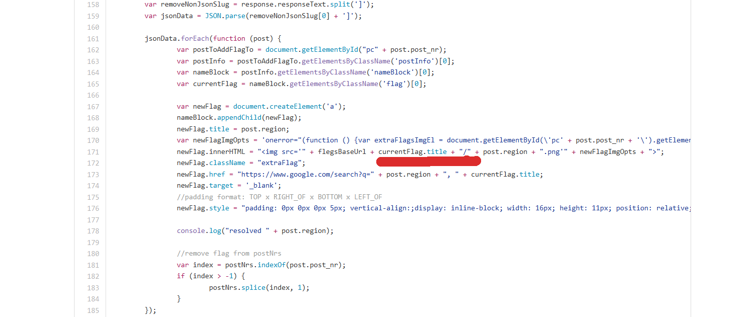

Figure 5: Delete what is underlined in red